Chapter 2, Solution 66

20 kΩ/V = sensitivity = 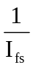
i.e., I_{fs} = 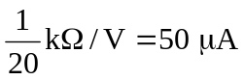
The intended resistance R_{m} = 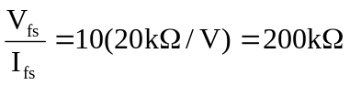
- 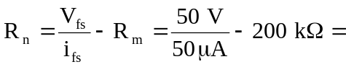 800 kΩ
- p = 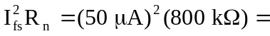 2 mW

